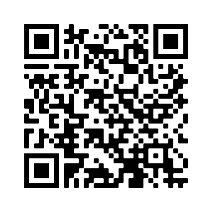


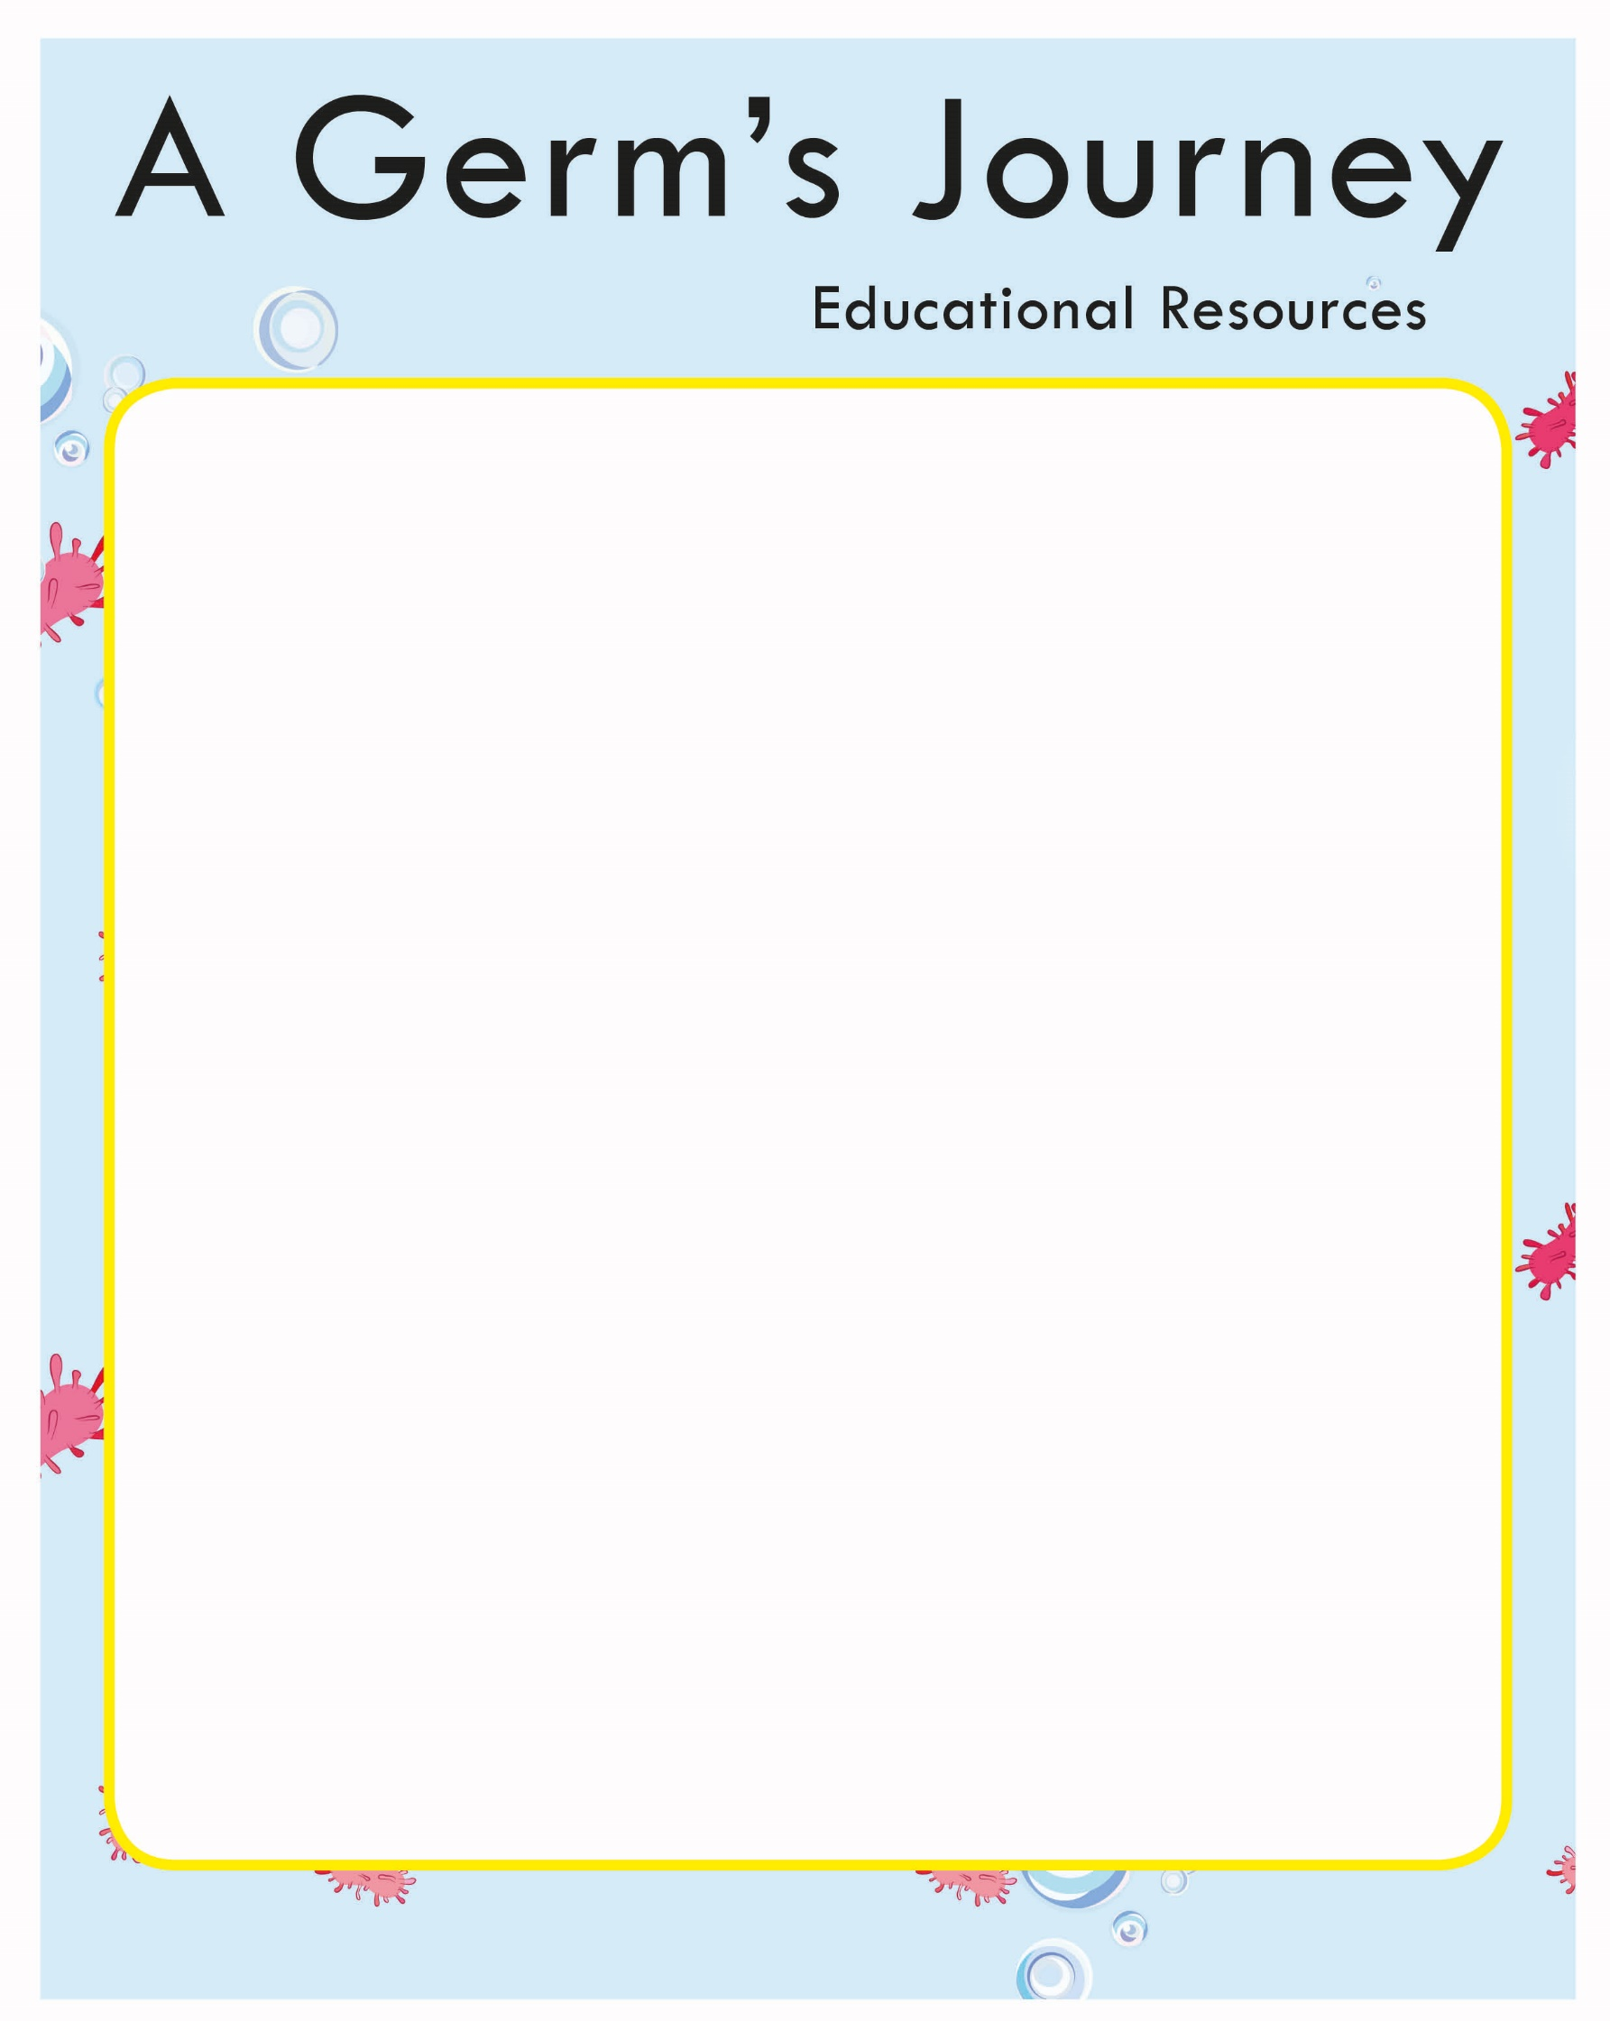

Handwashing Song

Scrub, scrub, scrub in between your fingers
Scrub, scrub, scrub under your nails
Rubadub rub your hands together
Rubadub rub round your wrists

Number One: Get your clean water
Number Two: Get your hands wet
Number three: Wash them with soap
Can you see the bubbles yet?
Scrub, scrub, scrub in between your fingers
Scrub, scrub, scrub under your nails
Rubadub rub your hands together
Rubadub rub round your wrists
Number Four: Wash off the bubbles
Number Five: Is the water clean?
Number Six: Now dry your hands
Remember germs can’t be seen
Bubble, bubble, bubble. Bubble, bubble, bubble. Bubble, bubble, bubble. I’m washing my hands!
Bubble, bubble, bubble. Bubble, bubble, bubble. Bubble, bubble, bubble. I’m washing my hands!
Scrub, scrub, scrub in between your fingers
Scrub, scrub, scrub under your nails
Rubadub rub your hands together
Rubadub rub round your wrists
BYE BYE GERMS!

